BISHOP GROSSETESTE UNIVERSITY
ANNUAL DIVERSITY AND EQUALITY MONITORING REPORT

Academic Year 2014-2015

- INTRODUCTION

This is the University’s Annual Equality Monitoring Report for academic year 2014/15. It has been prepared by the Equality and Diversity Committee and provides a summary of the equality-related data that we have gathered over the year alongside data gathered in previous years. These data provide us with an evidence-based approach to equality, enabling the University to prioritise and focus our limited resources on specific equality issues.

Publication of these data also demonstrates our compliance with the requirement of the Public Sector Equality Duty to publish relevant equality information and supports the University in identifying activity to meet the three elements of the general equality duty, which are to have due regard to the need to:

eliminate unlawful discrimination, harassment and victimisation and other conduct prohibited by the Equality Act 2010
advance equality of opportunity between people from different groups
foster good relations between people from different groups

Sector-wide equality data - taken from the Equality Challenge Unit’s publication Equality in higher education: statistical report 2015 and also from the online Higher Education Information Database for Institutions (Heidi) - are included in this report to indicate how the University compares with the national picture in key areas. It should be noted that throughout this report data is reported in very small numbers which means that caution is required when interpreting meaning.

In line with the Equality Duty the University set a number of equality objectives which were published in April 2012. These objectives consist of three broad, over-arching objectives and a series of specific goals under each.
Each year the Equality and Diversity Committee identify key priorities which become the focus of the work on equality for the forthcoming year. Progress on the 2014-15 priorities is detailed in this report.
These are included as attachment 1.

The overarching equality objectives and associated actions will be reviewed in 2016 and a revised action plan drafted and approved by the Diversity & Equality Committee. These revised objectives will be monitored throughout the year by the committee.

2. STAFF DATA

Staff Gender

Table 1: Gender of BGU staff, 2010/11, 2012/13, 2013/14 and 2014/15

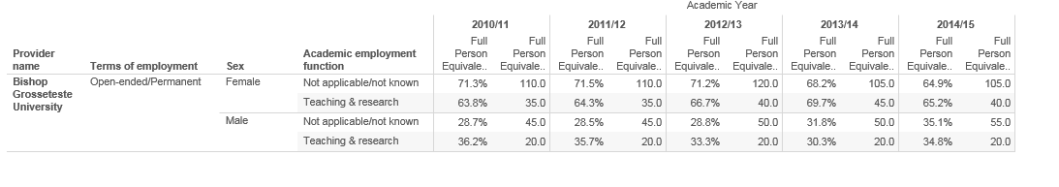
For the period 2014/15 at BG 66% of staff were female and 34% male. The proportion of all male staff at BGU is lower than the Cathedral University Group HEI sector average and has remained relatively constant at 31%,30% and 32% for the previous three years.

The proportion of male permanent academic staff (Teaching & Research) at BGU has increased from 30.3% to 34.8% but is still below the national average in comparison with the Cathedral University Group HEI sector where 47% of all academic staff (Teaching & Research) are male.

Staff Ethnicity

Table 2: Ethnicity of BGU staff, 2010/11, 2012/13, 2013/14 and 2014/15

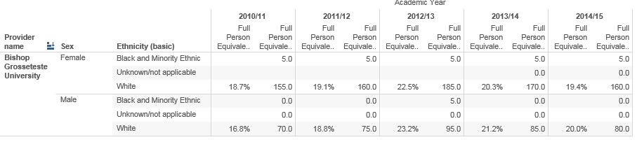

1.8 % (5) of BGU staff have a UK BME background; this is consistent with the previous year. This remains a low figure when compared to the Cathedral Group HEI sector as a whole where the figure was 6.5% in 2014/15.

Figure1. Ethnicity in Comparison with Cathedral University Group

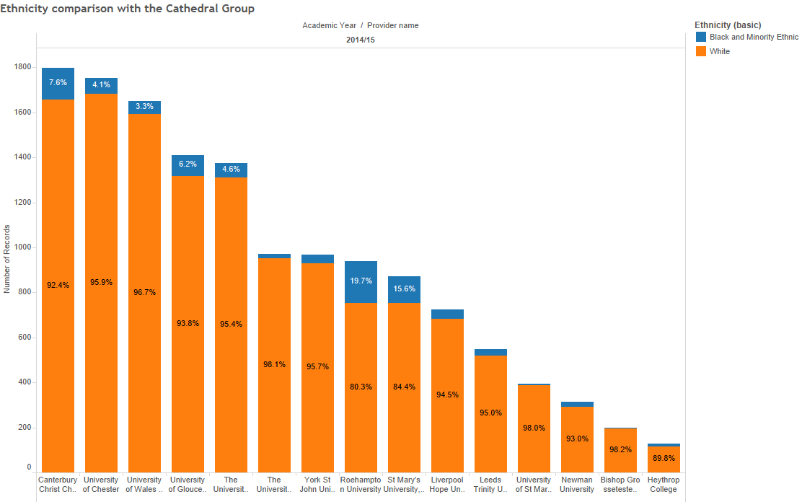

All of these staff at BGU are female and there are no males from a BME background. All of these staff are on permanent contracts. Increasing the number of BME staff will remain as an item to address within the equality aims. Applications and appointments of BME individuals are monitored by the committee and the figures are illustrated here.

Table 3: Staff characteristics all levels, including casuals 2014/15

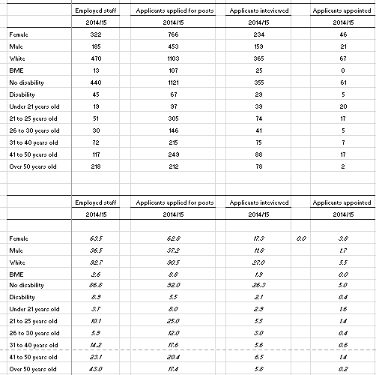

Staff Disability

Table 4: Disability declaration of BGU staff, 2010/11, 2012/13, 2013/14 and 2014/15

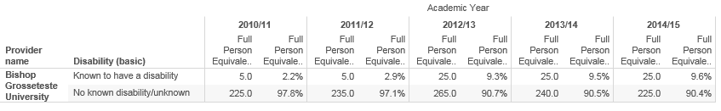

9.6% (25) of BG staff declared a disability. This is slightly higher than the Cathedral Group HEI sector average where 6.15% of staff disclosed as being disabled.

Figure 2: Disability comparison with the Cathedral University Group

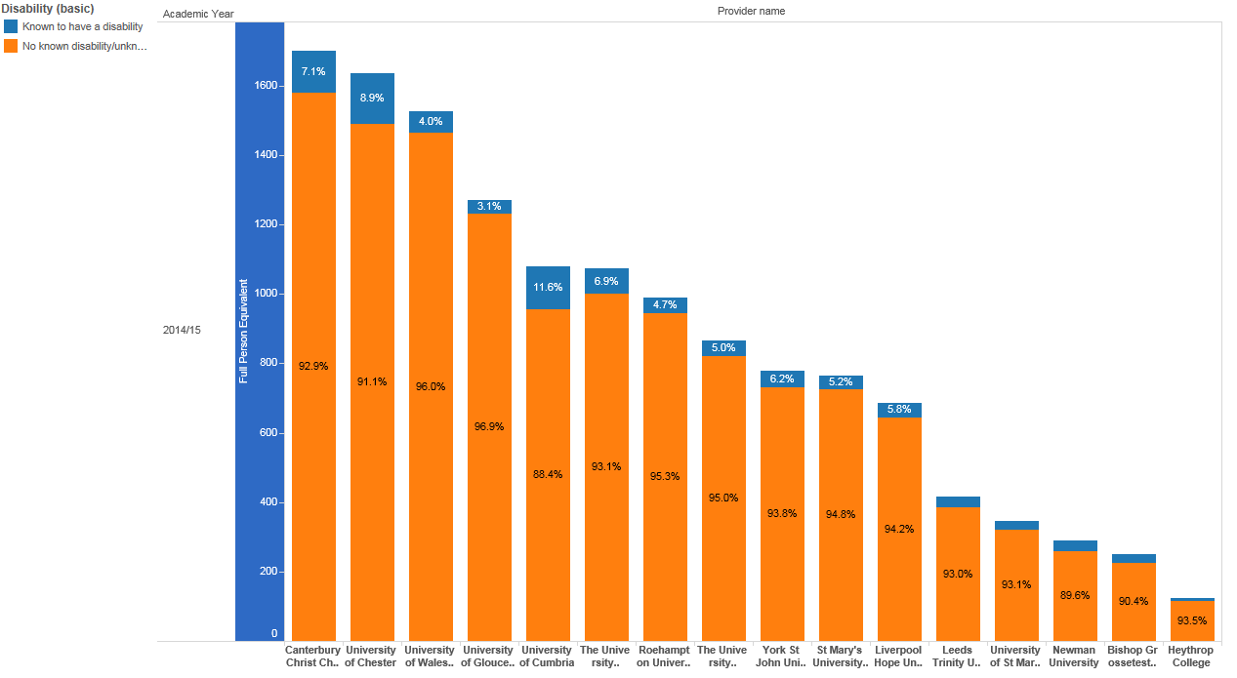

Table 5: BGU staff Disability Reasons, 2014/15

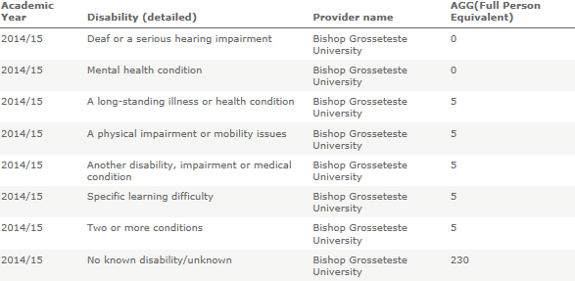

The disclosure rate continues to be a positive feature at BGU compared with other institutions. The proportion of all disabled staff 9.5% (25) were evenly disclosed across 5 various disabilities.

Age

Table 6: Age of BGU staff, 2010/11, 2012/13, 2013/14 and 2014/15

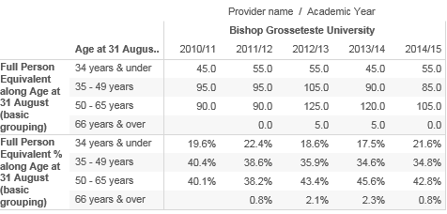

42.8% of BGU staff are aged between 50-65 years. This is higher than the Cathedral Group HEI sector average where 36.18% of staff are aged between 50-65 years.

Figure 3: Age Comparison with Cathedral University Group

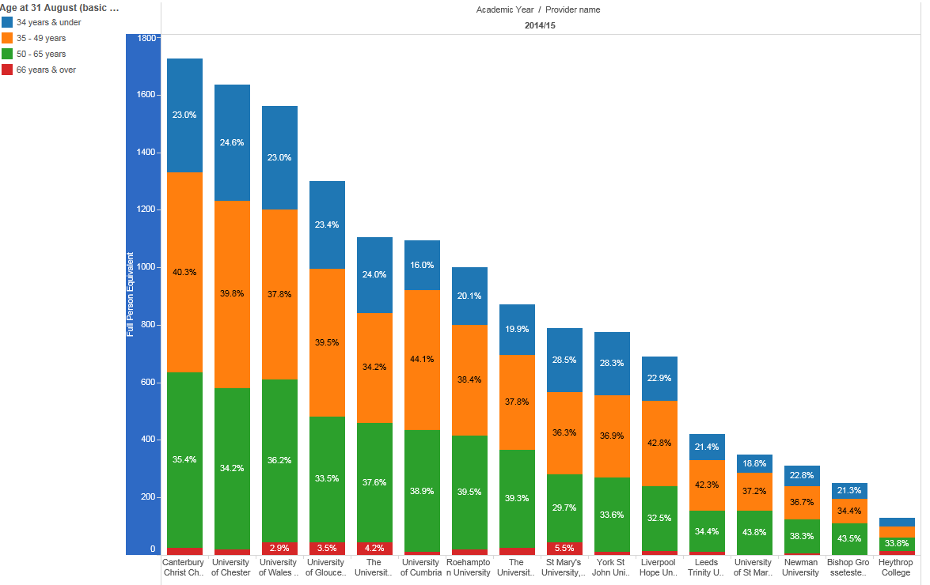

Source: HESA staff record 2010-11 to 2014-1

3. STUDENT DATA

Student applications

The conversion of applications to enrolments remains positive for each of the protected characteristic groups, each having a higher rate of applications to enrolments in 2014/15 compared with the total for all undergraduates. The conversion rate for disabled applicants is almost 20 percentage points higher than for all undergraduate applicants and 6 percentage points higher than last year.

Ethnicity data was missing for almost half of the applications so has not been included in the analysis. (Table 3).

 | Applied | Enrolled | % enrolled  of applied | Percentage point  difference to  2013-14
BME | NA | 22 | NA | NA
White | NA | 697 | NA | NA
Disabled | 254 | 137 | 54% | +6
No known disability | 1849 | 590 | 32% | -1
Male | 405 | 126 | 31% | -4
Female | 1698 | 601 | 35% | +1
Mature | 397 | 244 | 61% | +2
Young | 1706 | 483 | 28% | +2
All | 2103 | 727 | 35% | 0

Table 1: BGU undergraduate applications and enrolments, 2014/15

Student enrolments (Figure 1)

The gender balance of the student population has remained steady over the last four years at around 5:1 female to male students. The high ratio of females to males reflects the portfolio of subjects on offer at BGU and is in line with the ratio on first degree comparable subjects across the UK.

The proportion of students identifying themselves as Black or Minority Ethnic (BME) remains steady at around 3 per cent in 2014/15 and is in line with the local population from which BGU recruits.

The proportion of students recorded as having a specific learning disability has steadily increased since 2010/11, from 4 per cent to 9 per cent in 2014/15. The proportion of students with a disability other than a learning disability has also increased over the same period, but at a slower rate (7% in 2010/11 to 9% in 2014/15), and is broadly in line with the proportion of working age Lincolnshire population who consider their day to day activities limited (8.7%).

The proportion of mature students in the student population (36% in 2014/15) has been in steady decline since 2010/11 (48.3%), in line with national trends.

Figure 1: All enrolled students 2010/11 to 2014/15 by gender, ethnicity, disability and age
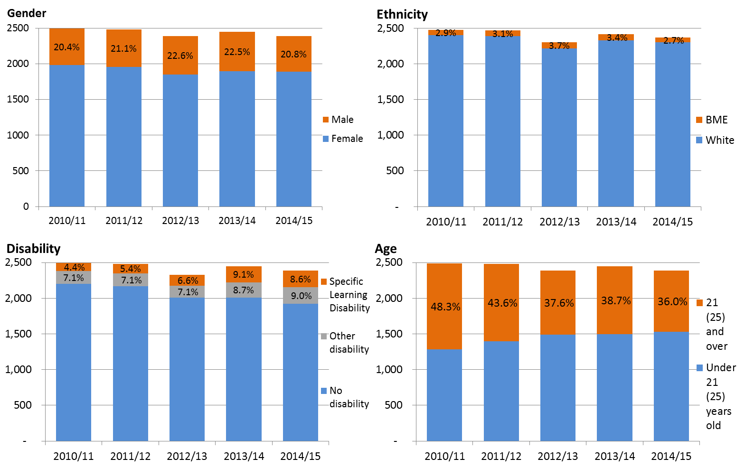

Student retention and progression (Figure 2)

90 % of males at undergraduate level were retained compared with 94% of females. Males had higher rates of referral and slightly higher rates of withdrawal and deferral/intercalation. Sector wide statistics show that a lower proportion of male entrants continued or qualified in 2013/14 than female entrants (89.7% and 91.8% respectively).
There was no difference in retention rates for undergraduate mature students compared with undergraduate students aged under 21. However, mature students had slightly lower rates of progression as higher proportions had deferred or intercalated.
Sector wide statistics show the proportions of entrants continuing or qualifying were lower among mature students than for entrants aged under 21.⁴
There was no difference in retention or progression rates between White and Minority Ethnic students.
Sector wide statistics show that overall, a higher proportion of white entrants continued or qualified (91.8%) than BME students (87.9%). However, continuation/qualification rates varied considerably by ethnic group, ranging from 93.8% for Chinese entrants to 82.7% for entrants from an other black background (an 11.1 percentage point difference).⁴
Although there was little difference in retention rates for disabled students compared with other students, a smaller proportion progressed or graduated to the next level of study (90% compared with 94% of students without a disability). Sector wide statistics show that a lower proportion of UK domiciled first degree disabled entrants continued to 2013/14 or qualified (89.6%) than non-disabled entrants (91.0%).

Figure 2: Undergraduate progression 2013/14 by characteristic
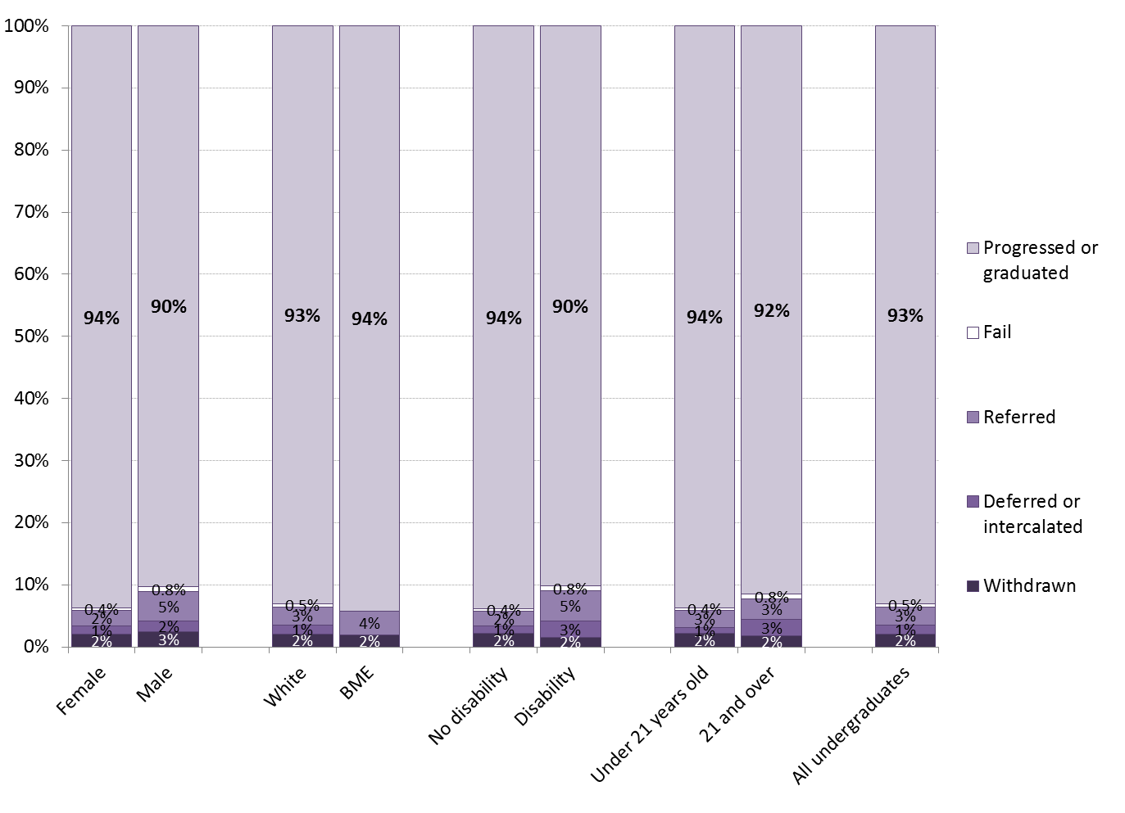

Student attainment

There was very little difference between the proportion of males and females achieving good degrees but a higher proportion of males left with 3rd class honours (8% against 2%).

Across English HE providers in 2013/14, a higher proportion of female qualifiers received good degrees than male qualifiers (72.5% female/67.4% male)5.

Figure 3a: Degree classifications, females and males 2012/13 to 2014/15
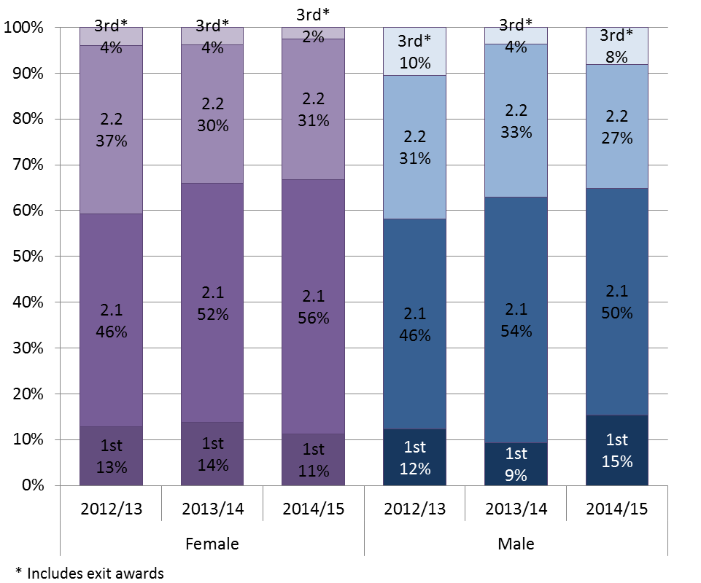

Statistics on degree outcomes by ethnicity are volatile owing to the small number of minority ethnic students in the graduating population. There were 20 minority ethnic students in the 2014/15 graduating population so one student contributes 5 percentage points to the statistics. With this in mind, the statistics show that there was little difference in degree outcomes for minority ethnic students compared with other students.

Across the UK the ethnicity degree attainment gap was 15.2 percentage points. 75.6% of white qualifiers received a first/2:1 compared with 60.4% of BME qualifiers.

Figure 3b: Degree classifications, 2012/13 to 2014/15 by ethnicity
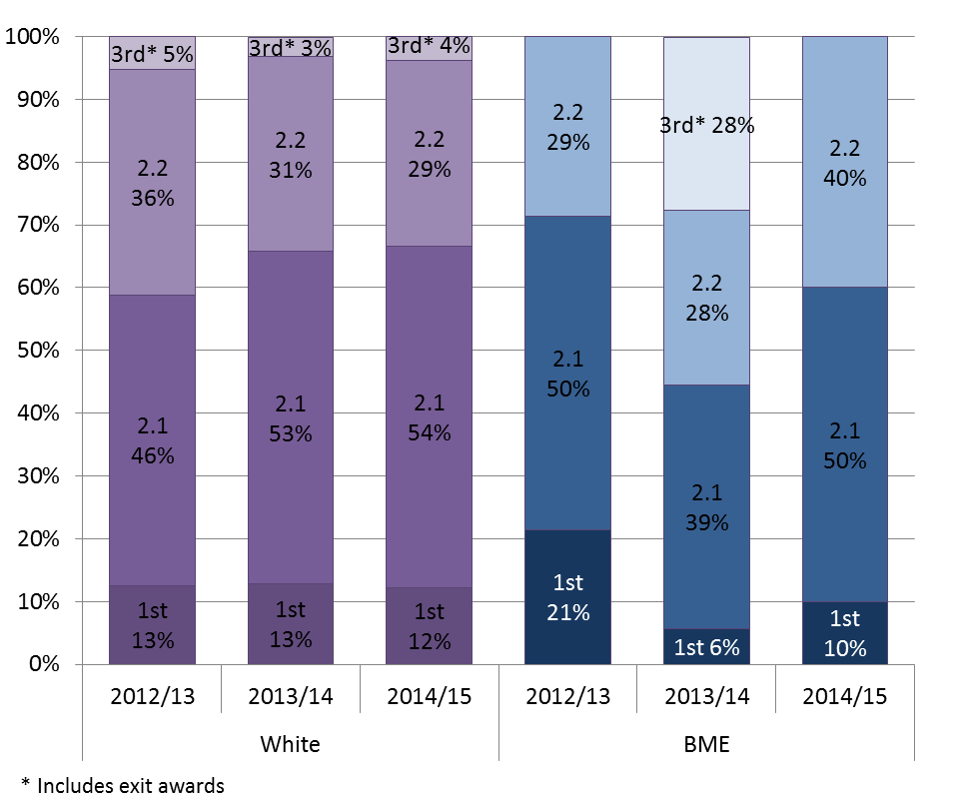

As in previous years, a smaller proportion of disabled students compared with non-disabled students achieved good degrees but the gap has decreased compared with the previous year. The main difference between these two groups of students is the proportion of Firsts awarded (7% of students with a disability achieved a 1st compared with 14% of those with no disability).

Sector level statistics show very little difference in the proportion of disabled students achieving good degrees compared with non-disabled students⁷.

As in previous years, a higher proportion of mature students achieved 1sts or 2.1s than those aged under 21 years (72% compared with 64%).

Statistics for the sector show that the proportion of qualifiers receiving a first increased with age. However, the proportion of students receiving a third/pass also increased with age⁷.

Figure 3c: Degree classifications, 2012/13 to 2014/15 by disability
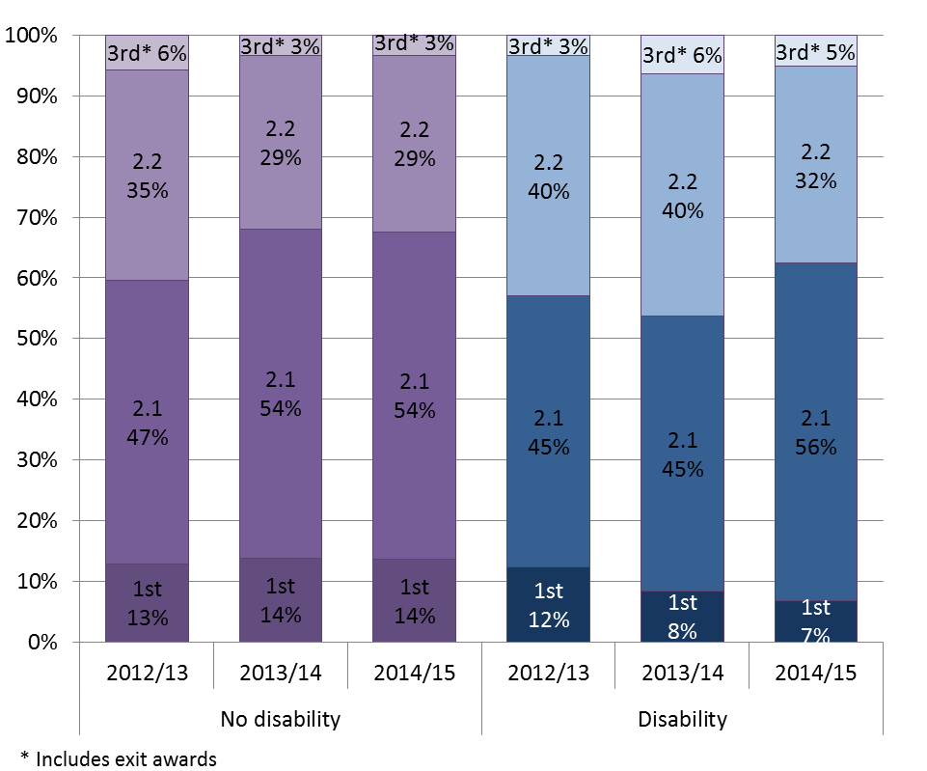

Figure 3d: Degree classifications, 2012/13 to 2014/15 by age
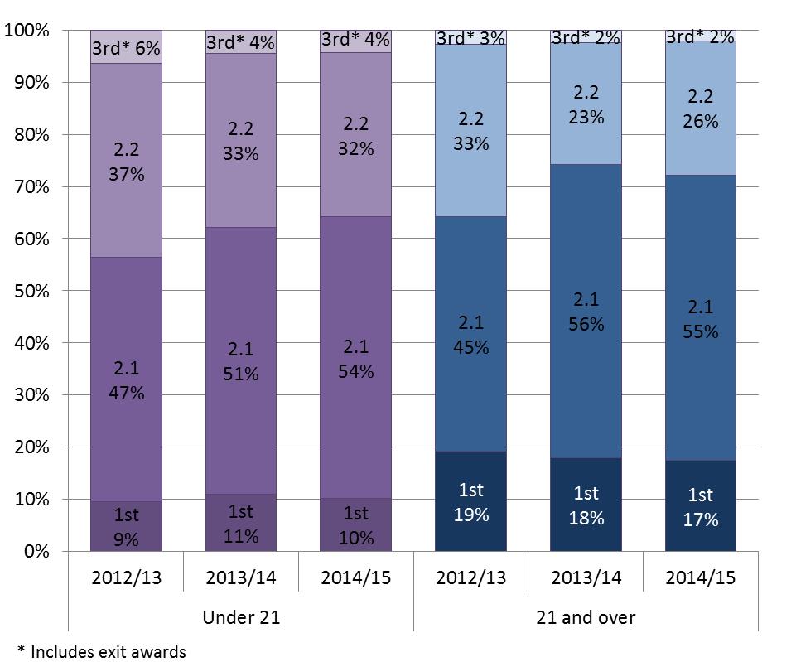

Student satisfaction

According to the 2015 National Student Survey, 79 per cent of students with a learning disability agreed that ‘Overall I am satisfied’ compared with 77 per cent of those with some other disability and 86 per cent of those without a disability. Those with a learning difficulty were less satisfied that they have been able to access specialised equipment, facilities or rooms, that any changes in the course or teaching have ben communicated effectively, that the timetable works efficiently and that they have received sufficient advice and support with their studies. (Figure 4a)

Students with a disability were less satisfied that ‘as a result of the course I feel confident in tackling unfamiliar problem’, ‘my communication skills have improved’ and ‘staff are good at explaining things’ but are more satisfied with the Students’ Union. (Figure 4a).

Overall, females were more satisfied than males, with 86% stating overall satisfaction compared with 80% of males. Female versus male satisfaction swung different ways depending on the question. Males were less satisfied that any changes in the course or teaching have been communicated effectively and that ‘assessment arrangements and marking have been fair’ but more satisfied that ‘staff are good at explaining things’. (Figure 4c).

89% of mature students agreed that overall they were satisfied with their institution, compared with 83% of young students. A larger proportion of mature students responded positively to 18 of the 23 questions. The biggest difference by age between responses was for the course is well organised and running smoothly (85% mature compared with 66% young) followed by ‘any changes in the course or teaching have been communicated effectively’ (83% mature agree compared with 71% young). (Figure 4d).

The largest differences in response by ethnicity related to the library (55% non-white satisfaction compared with 73% white) the Students’ Union (50% non-white satisfaction compared with 67%) and being able to contact staff when needed (67% non-white satisfaction compared with 83% white). Non-white students were more satisfied that the course is intellectually stimulating (95% non-white compared with 83% white) and that staff are enthusiastic about what they are teaching (100% non-white compared with 90% white). (Figure 4b).

Figure 4a: Student satisfaction by disability, 2015
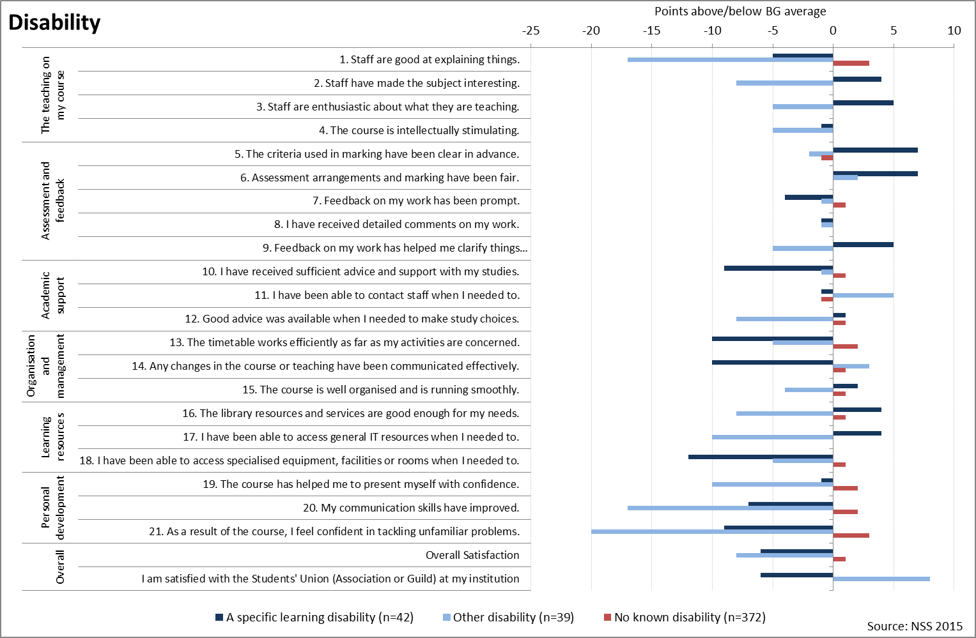

Figure 4b: Student satisfaction by ethnicity, 2015
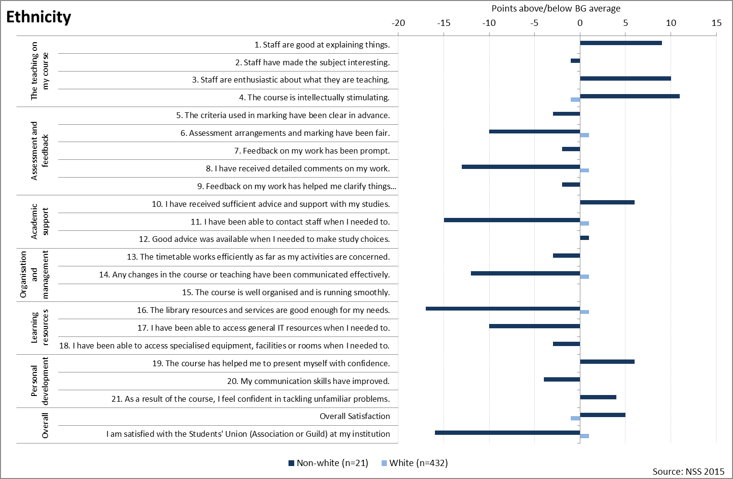
Figure 4c: Student satisfaction by gender, 2015
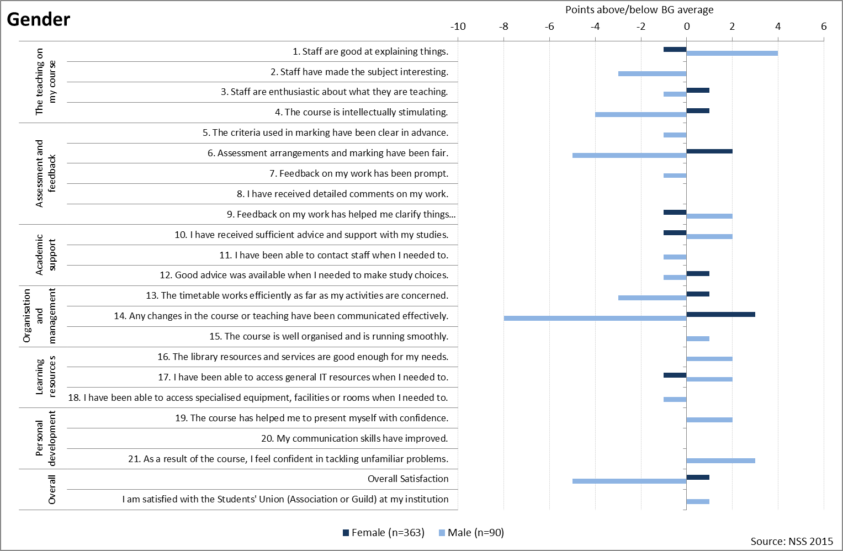

Figure 4d: Student satisfaction by age, 2015
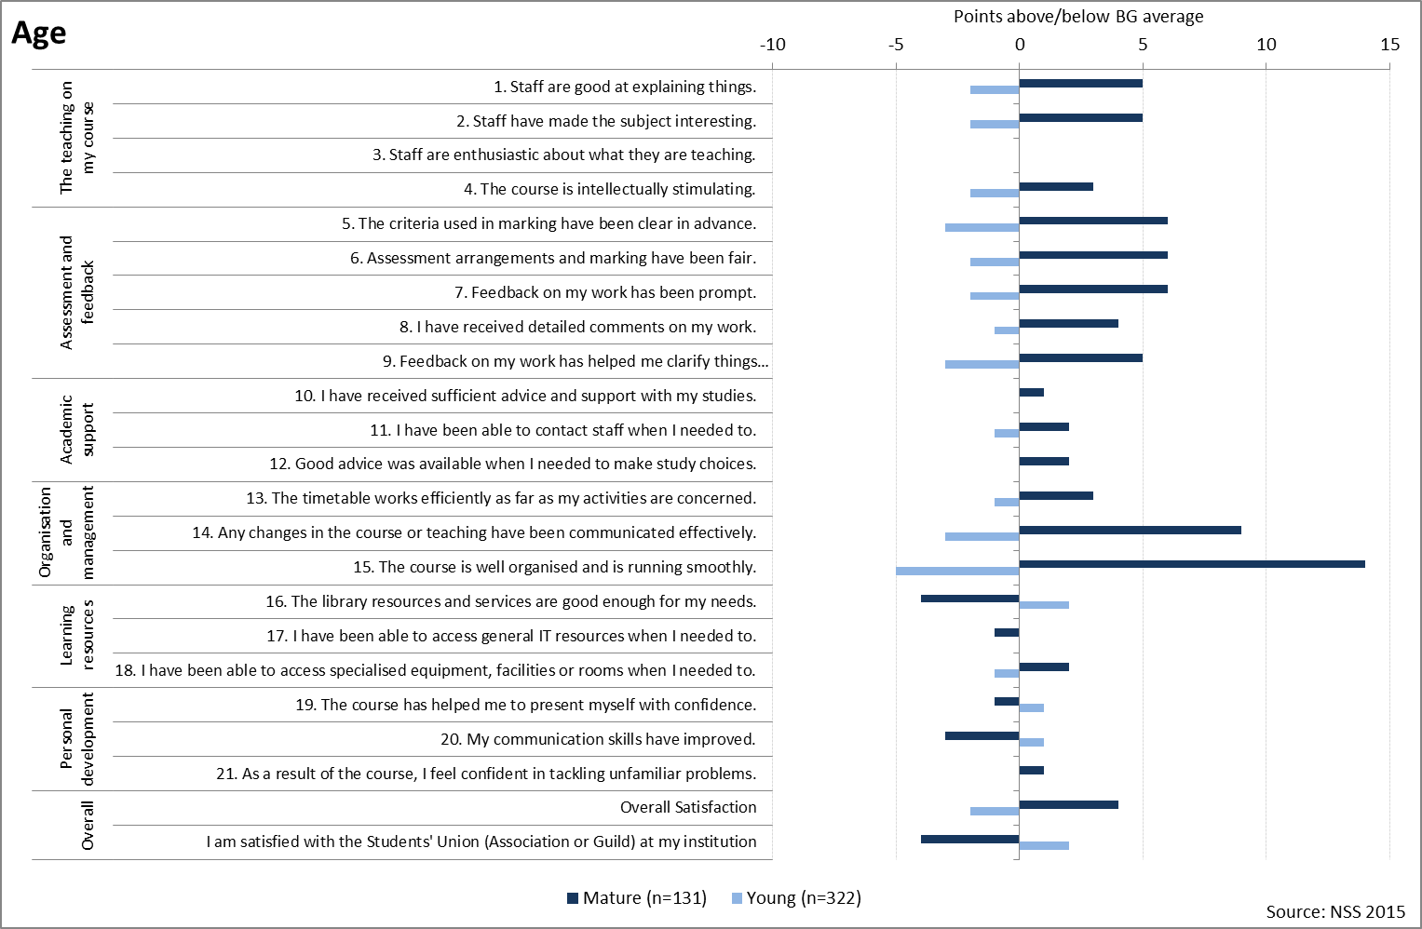

Student destinations

Results from the Destinations of Leavers from Higher Education Survey 2013/14 show that a higher proportion of males than females were in full time work (71% against 61%), although this difference is diminished once those who were primarily working but also studying are included. A slightly higher proportion of females than males (11% against 7%)were engaged in full-time study 6 months after graduating, reflecting the high number of Foundation degree students, primarily females, who go onto complete Top-up degrees. (Figure 5a).

Figure 5a: Employment activities 6 months after graduating, by gender (%)
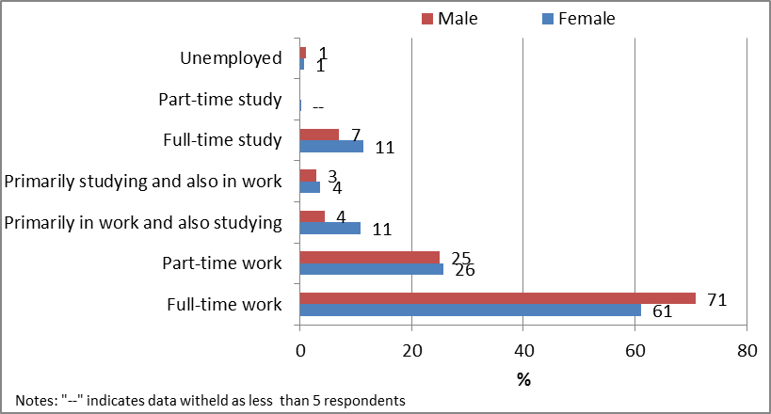
Source: DLHE 2013/14

The leavers who were under 21 when they first enrolled on their degree were more likely to be in full time study or full time employment 6 months after graduating, whereas mature leavers were more likely to be combining work and study. (Figure 5b).

Figure 5b: Employment activities 6 months after graduating, by age (%)
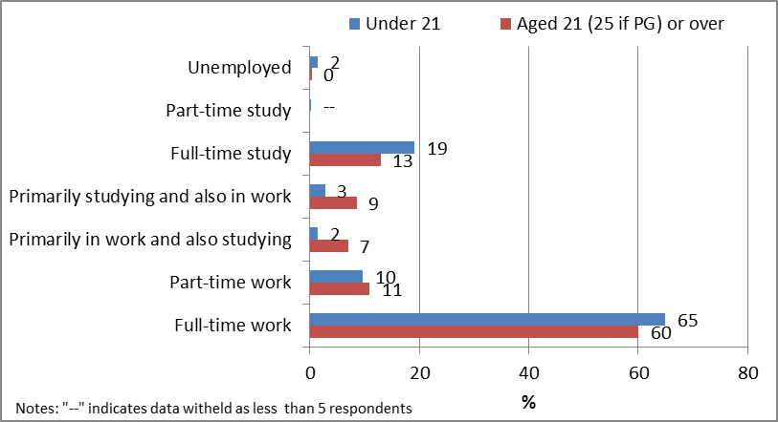
Source: DLHE 2013/14

A larger proportion of minority ethnic leavers compared with white leavers were in part-time work or primarily in work and also studying. (Figure 5c).

Figure 5c: Employment activities 6 months after graduating, by ethnicity (%)
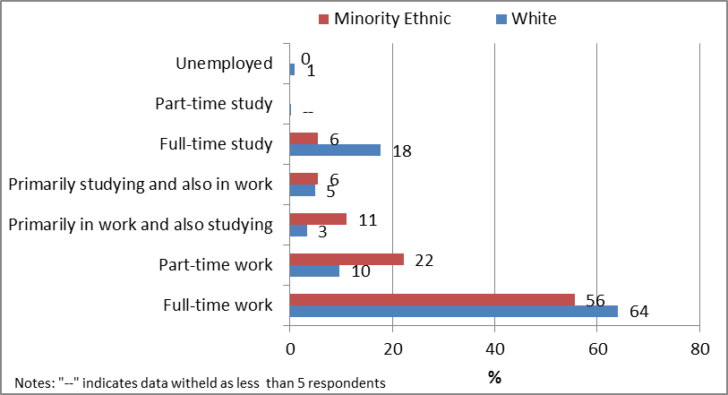
Source: DLHE 2013/14

Three per cent of disabled leavers were unemployed 6 months after graduating compared with 1% of those without a disability. A higher proportion of disabled leavers were in part-time work than non-disabled leavers (16% against 9%) and vice versa for full-time work (54% against 65%). (Figure 5d)

Figure 5d: Employment activities 6 months after graduating, by disability (%)
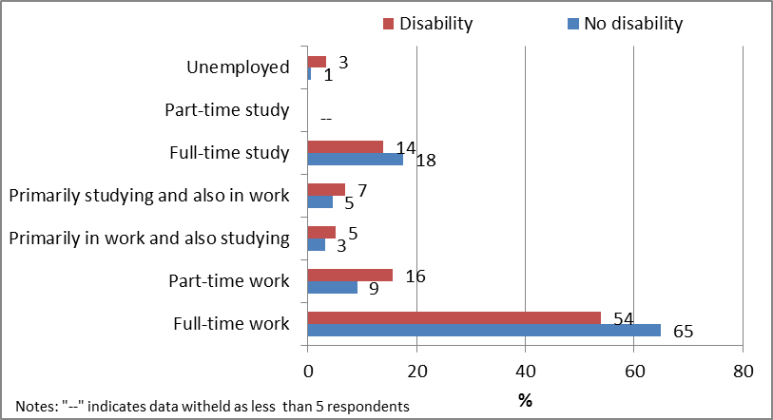
Source: DLHE 2013/14

16% of HE enrolments on undergraduate Education subject programmes were male, HESA student record 2013/14.
2.4% of Lincolnshire population is BME. 2011 Census http://www.research-lincs.org.uk/2011-Census.aspx
2011 Census http://www.research-lincs.org.uk/2011-Census.aspx
Equality Challenge Unit (2015). Equality in Higher Education: statistical report 2015. London: ECU
Equality Challenge Unit (2015). Equality in Higher Education: statistical report 2015. London: ECU
Equality Challenge Unit (2015). Equality in Higher Education: statistical report 2015. London: ECU

