Document Administration

Document Title: | Outbreak Response Plan
Document Category: | Procedure
Version Number: | 1.1
Status: | Approved
Reason for development: | To provide clarity over the University’s arrangements for an outbreak of Covid-19 amongst students and/or staff and/or visitors (including tenants, guest lecturers and contractors)
Scope: | The plan covers all University business
Author / developer: | Business Continuity Group (Covid-19)
Owner | Deputy Vice-Chancellor
Assessment:  (where relevant) | ☒Equality Assessment  ☐Legal | ☐Information Governance  ☐Academic Governance
Consultation:  (where relevant) | ☒Staff Trade Unions via HR  ☒Bishop Grosseteste University Students’ Union  ☒Any relevant external statutory bodies
Authorised by (Board): | Vice-Chancellor’s Executive Group
Date first authorised: | September 2020
Date current version authorised: | October 2020
Date current version effective from: | October 2020
Date next review due to commence*: | This is a ‘live’ document and like the University Risk Assessment for Covid-19 and the accompanying ‘Lifting the Lockdown’ guidance, is subject to weekly review
Document location: | University website
Document dissemination / communications plan | Communication to all relevant stakeholders will be managed through the University’s communications team
Document control: | All printed versions of this document are classified as uncontrolled. A controlled version is available from the University Website
Alternative format: | If you require this document in an alternative format, please contact governance@bishopg.ac.uk

*Please note the document remains valid until formally revoked or replaced by the University.

Version Number | Date Authorised | Summary of Key Changes
1.1 | October 2020 | Clarification added to flow diagrams.  Response to comments from local Health Protection Team on version 1.0.  Clarification added about students in contact with staff member who has a positive test.
Version Control Table

INTRODUCTION

- This policy sets out the arrangements to be implemented in the event of an outbreak of Covid-19 at Bishop Grosseteste University (BGU). It provides a response informed by legislation, government guidance and advice from National Institute for Health Protection (NIHP), specifically ‘Covid-19 Early Outbreak Management’ and ‘Higher Education: Reopening Buildings and Campuses’.

- The University will remain engaged with networks of influence and support locally (e.g., Department of Public Health, Lincoln BIG, Local Resilience Forum) regionally (e.g., Lincolnshire County Council, Lincolnshire Police) and nationally (e.g., GuildHE, Universities UK).

ORGANISATIONAL CONTEXT

- Following a period of ‘lockdown’ which began in March 2020, consistent with national government advice, the University has put in place a programme of work to enable students, staff and visitors (including tenants) to return to the campus and has re-introduced ‘face-to-face’ working under a set of strict protocols concerned with health, safety and well-being.

- Government restrictions on behaviour of the general public eased during August 2020 but by early September there were strong indications that the number of cases was rising especially amongst young people. The return of students in relatively large numbers in late September who will be resident on campus or in University-managed accommodation in the city of Lincoln presents a heightened risk of an outbreak.

- Induction for new and returning students emphasises the importance of appropriately responsible behaviour and information is available to students and staff through the guidance for prospective students and the University’s Working Together Protecting Each Other website.

- As far as practicably possible, learning and teaching arrangements have allocated students to ‘bubbles’. New students in University-managed accommodation have also been assigned to programme-related bubbles. These will assist with rapid action in the event of an outbreak. Most students are in private accommodation or based at their permanent home address and will form their own household bubbles.

- The University has introduced a Covid-19 Code of Conduct (Students) to ensure that the BGU community can stay safe together. It offers guidance about the measures that have been introduced (e.g., observing social distancing, one-way systems, the use of face coverings and regular hand washing/ hand sanitisation) and emphasises compliance with government’s self-isolation and quarantine regulations as well as associated University guidance.

- University staff are also assigned to workplace bubbles for their on-campus activities. Working arrangements have been agreed at departmental level and risk assessed. These include rotas and ‘shift patterns’ and have sought to reduce footfall on campus, especially on the busiest days of timetabled student learning.

- Students, staff or visitors to the University are being told to get tested if they experience any of the Covid-19 symptoms, even if only mildly:
- A high temperature
- A new, continuous cough
- A loss or change in sense of smell or taste.

COVID OUTBREAK RESPONSE GROUP (CORG)

- A sub-group of the Business Continuity Group (BCG), the CORG comprises:
- Deputy Vice-Chancellor (DVC), chair
- Bishop Grosseteste Students’ Union (BGSU) representative
- Campus Operations & Accommodation Manager (COAM)
- Director of Estates and Facilities (DoEF)
- Director of Human Resources (DoHR)
- Director of Marketing, Recruitment and Communications (DoMRC)
- Health & Safety Officer (H&SO)
- Registrar & University Secretary (R&US)
- Pro Vice-Chancellor – Students (PVC).

- Its purposes are to:

  - Monitor positive test cases across the University for students, staff and visitors

  - Determine whether isolation measures have to be escalated based on the circumstances of each positive test result

  - Liaise with and report to the local Health Protection Team (HPT) as appropriate

  - Liaise with BCG & VCEG over broader lockdown measures.

COVID OUTBREAK AMONGST STUDENTS – PRINCIPLES AND PRACTICE

- Resident Student – Single Incident
- Accommodation Team to ensure that student has understood key guidance (see annexes 1 & 2)
- Accommodation Team to instruct resident student’s bubble to self-isolate
- HSO to inform HPT when more than one confirmed case in 14 day rolling period – Test & Trace
- HPT will confirm action required
- Timetabling Team to confirm teaching spaces accessed by student and these to be immediately taken out of use
- Sanitisation of teaching spaces to be undertaken immediately to minimise disruption for other students
- All other areas of campus are sanitised daily
- Student to confirm if University social spaces (e.g., BG Futures, refectory, sports centre) have been used – if so, close immediately and sanitise
- Communications to students and staff to be provided.

- Non-Resident Student – Single Incident
- Confirm if student is in private accommodation or living at home
- BGU to inform student to contact managing agent or ‘landlord’
- Student to inform occupiers of property in a multi-tenanted building who must also self-isolate
- Student to confirm if access to food, medication etc is available
- BGU to provide support if required
- HSO to inform HPT when more than one confirmed case in 14 day rolling period – Test & Trace
- HPT will confirm action required
- Timetabling Team to confirm teaching spaces accessed by student and these to be immediately taken out of use
- Sanitisation of teaching spaces to be undertaken immediately to minimise disruption for other students
- All other areas of campus are sanitised daily.
- Student to confirm if University social spaces (e.g., BG Futures, refectory, sports centre) have been used – if so, close immediately and sanitise
- Communications to students and staff to be provided.

- Household Outbreak
- Isolation of one ‘household’ monitored with one or more positive cases
- Two ‘households’ in a hall of residence consider isolating floors
- Three or more ‘households’ in a hall of residence – isolate the hall
- Suspend on-campus in person social activity.

- Programme / Course Outbreak
- One positive case per split group – monitor
- Two positive cases in the same academic bubble from same household – monitor
- Three or more positive cases in the same academic bubble from more than one household – in person delivery to academic bubble suspended for 14 days
- If cases involve students with placement activity –
  - All students in an academic bubble with a suspected / positive test case would suspend their placement visits in a precautionary isolation
  - If a student is part of a placement bubble required to self-isolate, then the student would also self-isolate from the University in-person classes.

- In the event of contact with someone who has tested positive, social isolation must be maintained for the full 14 days even if a test has a negative result as it is still possible to develop infection.

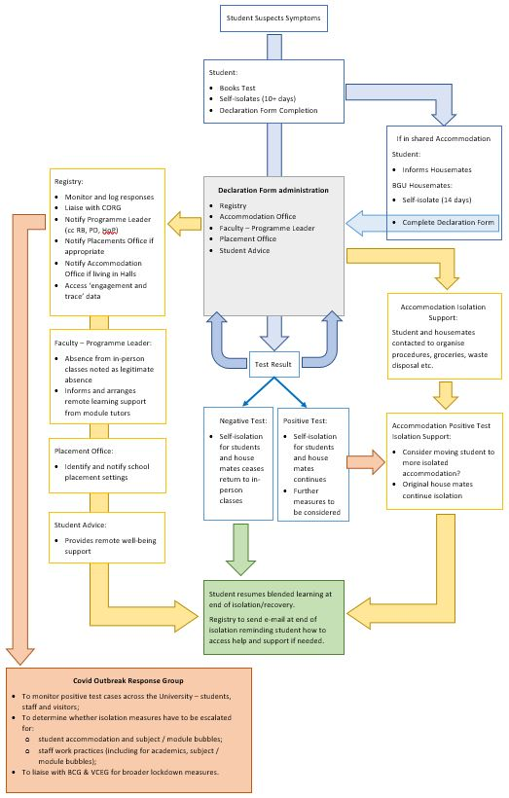
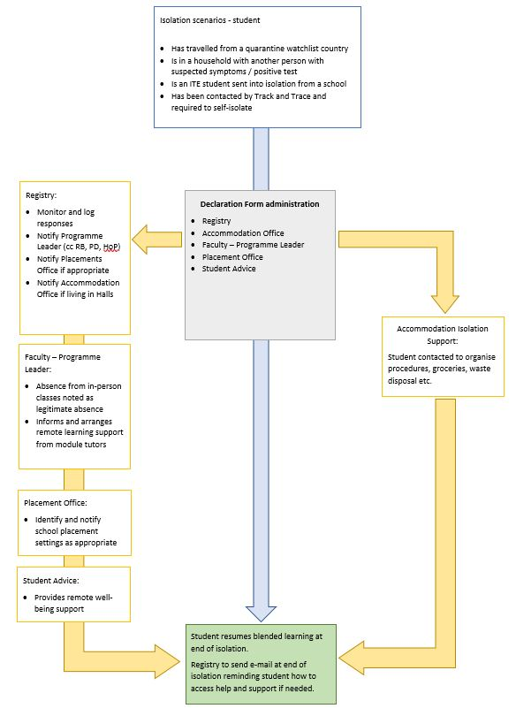

COVID OUTBREAK AMONGST STAFF – PRINCIPLES AND PRACTICE

- Member of Staff – Single Incident
- Staff member to self-isolate upon the result of a positive test
- Staff member’s colleagues or students in bubble to self-isolate
- HSO to inform HPT when more than one confirmed case in 14 day rolling period – Test & Trace
- HPT will confirm action required
- Work base / office to be sanitised
- Timetabling Team to confirm teaching spaces accessed by a member of academic staff and these to be immediately taken out of use
- Sanitisation of any affected teaching spaces to be undertaken immediately to minimise disruption for other students
- Office space to be quarantined until sanitisation has taken place
- All other areas of campus are sanitised daily
- Staff member to confirm if University social spaces (e.g., BG Futures, refectory, sports centre) have been used – if so, close immediately and sanitise
- Communications to students and staff to be provided.

- In the event of multiple cases amongst staff the CORG will make the decision regarding closing the campus to all staff and students with the exception of staff required to undertake statutory maintenance and sanitisation of all areas.
- If the decision is taken to close this will be for a period of 14 days
- The Library, Refectory, Curiousitea and Sports Centre will also be closed for the same duration
- Student accommodation will remain open with students remaining in their bubbles and requested to exercise in their bubbles for one hour per day on the playing field only
- Teaching to be delivered on-line
- Staff to work remotely for the duration of campus closure
- Communications to students and staff to be provided.

- In the event of a campus outbreak (i.e. positive test results across different parts of the University):
- Liaise with HPT
- Suspend in person learning for 14 days
- Suspend on-campus in person social activity
- Consider suspending placements.

- In the event of contact with someone who has tested positive, social isolation must be maintained for the full 14 days even if a test has a negative result as it is still possible to develop infection.

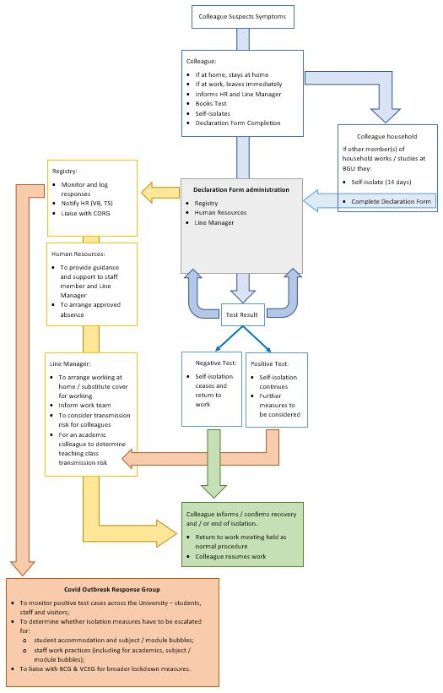
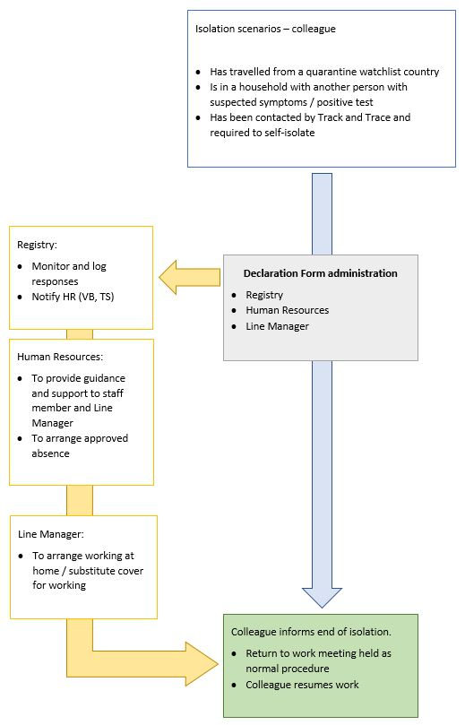

COVID OUTBREAK AMONGST VISITORS TO THE UNIVERSITY – PRINCIPLES AND PRACTICE

- The University welcomes visitors to the campus for a variety of purposes. These include tenants occupying accommodation in BG Futures, guest lecturers and contractors. The following applies to all of them.

- Visitor – Single Incident
- Visitor to self-isolate upon the result of a positive test
- Students or staff members in visitor’s bubble to self-isolate
- HSO to inform HPT when more than one confirmed case in 14 day rolling period – Test & Trace
- HPT will confirm action required
- Visitor and/or host of visitor to confirm areas of University visited and these to be immediately taken out of use
- Sanitisation of any affected areas to be undertaken immediately to minimise disruption for other students.
- All other areas of campus are sanitised daily
- Communications to students and staff to be provided.

- In the event of multiple cases amongst visitors the CORG will make the decision regarding closing the campus to all staff and students apart from staff required to undertake statutory maintenance and sanitisation of all areas.
- If the decision is taken to close this will be for a period of 14 days
- The Library, BG Futures, Refectory, Curiousitea and Sports Centre will also be closed for the same duration
- Student accommodation will remain open with students remaining in their bubbles and requested to exercise in their bubbles for one hour per day on the playing field only
- Teaching to be delivered on-line
- Staff to work remotely for the duration of campus closure
- Communications to students and staff to be provided.

- In the event of contact with someone who has tested positive, social isolation must be maintained for the full 14 days even if a test has a negative result as it is still possible to develop infection.

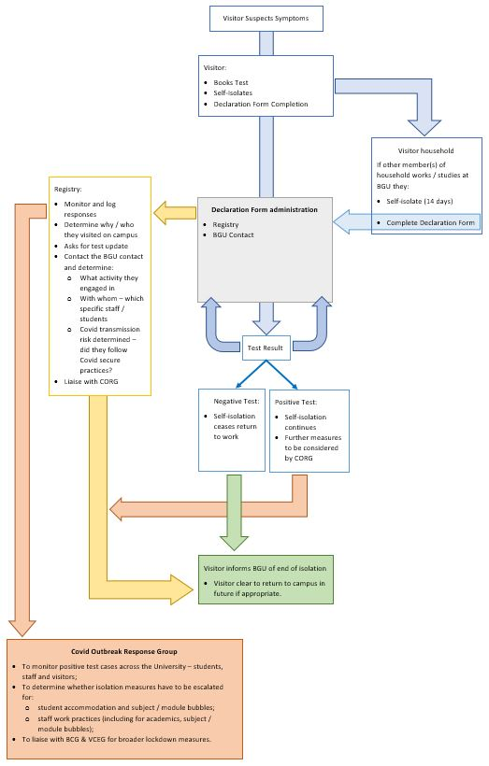
OUTBREAK IN THE LOCAL COMMUNITY

- In the event of an outbreak in the north of the city of Lincoln:
- Local lockdown - liaise with HPT
- Suspend in person learning for 14 days to avoid commuting students travelling to / from campus
- Suspend on-campus in person social activity
- Suspend placement activity as appropriate.

END OF AN OUTBREAK

- It is important to maintain vigilance for new potential cases whilst maintaining infection prevention and control principles. The University will be guided by HPT and other external agencies over a declaration about an outbreak being over. Key principles will include:
- there is no longer a risk to the public health that requires further investigation or introduction of additional control measures
- the number of cases has declined
- no new cases of confirmed or suspected COVID-19 within a continuous 14-day period.

DATA PROTECTION / GDPR

- Information relating to a student or staff member’s health should not normally be shared internally beyond those staff who require it for their role, or externally with third parties (other than public health authorities) without consent.

- On rare occasions it may be deemed necessary to share information with a third party such as the emergency services without a student or staff member’s permission. This would only be done in exceptional circumstances, in “life or death” situations where it is in the individual’s vital interests to do so. This should only be done in consultation with the relevant line manager and on the advice of registrar@bishopg.ac.uk.

- In these rare occasions, strictly limited information proportionate to the situation that has arisen may be disclosed to University staff or third parties, including health care professionals. If any such data is to be provided by email rather than verbally, this must be done appropriately and by taking the necessary precautions – by marking any message as strictly confidential and externally by encrypting the email in accordance with University policy. All information must be stored in line with the University’s Data Protection Code of Practice. Further information can be obtained from registrar@bishopg.ac.uk.

Annex 1 Shared accommodation - Living with Covid-19

For students living in shared accommodation during term-time are away from the family home the University is keen to share with you how you and your ‘housemates’ can stay safe. Many of you will be in private accommodation as well as in University accommodation, some in self-contained suites, others with en suite bathrooms or sharing bathrooms and kitchens.

General advice for living in University accommodation:
Students have signed to conform to the Terms & Conditions of their Contractual Agreement which covers behaviour and the COVID-19 Appendix (attached) also highlights:
- To behave responsibly with regard to social distancing, treating staff and fellow students with dignity and respect as outlined in the Student Charter and in the specific Covid-19 Code of Conduct (Students),
- You must only use your own crockery and cutlery, and not share it with others. You must always leave shared facilities clean after you have used them,
- To provide a safe living environment and thus, to protect all residents against the possible spread of coronavirus (or any other epidemic or pandemic disease), and to adhere to the UK Government’s advice on maintaining social distancing and all other advice and measures in connection with containing the disease and reducing the spread of the disease, until, the landlord/University otherwise confirms in writing, no Resident will be permitted to have a guest stay with them in The Accommodation. The landlord/University will keep this measure under review and if and when there can be a relaxation of this condition, residents of the accommodation will be informed.

For those living in self-contained suites - Crosstrends House
Your individual self-contained suite should be considered to be your household. You should follow Government advice on visiting other households and please socialise responsibly outside of your accommodation following social distancing protocols.
- Wear face coverings in communal stairs / corridors
- Handwash / sanitise when you return to and before you leave your flat
- Keep your bathroom and kitchen areas clean

For those living in University halls - Constant Stewart or Wickham Halls
We have put you into accommodation bubbles of ‘housemates’ grouped around a shared kitchen. This should be considered to be your ‘household’ and you should not visit other bubbles / households within the hall building. You may socialise with bubbles outside following social distancing protocols.
Within your accommodation bubble:
- Wear face coverings in communal stairs / corridors
- Handwash / sanitise when you return to and before you leave your flat
- Bathrooms:
- for those with en suite facilities, please keep these clean
- for shared bathroom users – only use your own towel(s), take-away your own toiletries and clean after use
- Kitchen – keep physically distanced, use your own crockery and cutlery, put away your own food and packets, clear and clean the facilities after use.

General advice for living in private houses and halls
If you live in a shared house or in a hall with shared kitchen / bathroom facilities you should consider this grouping to be your accommodation bubble / household.
You should follow Government advice on visiting other households and please socialise responsibly outside of your accommodation following social distancing protocols.
Please apply the guidance above as appropriate.

Generally, please note that, whilst socialising with housemates in your accommodation bubble is fine, inviting others in and holding house parties is not. We ask that you enjoy yourself responsibly and safely, protecting yourself, each other and the wider local community.
For further information please see:
Government advice for living in shared households: https://www.gov.uk/guidance/meeting-people-from-outside-your-household-from-4-july

Supporting students who have to self-isolate
If you suspect you have symptoms or have tested positive you should see https://www.nhs.uk/conditions/coronavirus-covid-19/ and follow the protocols outlined in the relevant sections of this web-page – you must self-isolate and inform the University using the Declaration Form enabling the University to contact you and provide specific support.
If you or someone in your accommodation bubble / household suspects they have Covid-19 symptoms or have been tested positive then the whole bubble / household MUST self-isolate.
You must not leave your accommodation except in the case of an emergency (e.g. fire alarm or seeking medical help) and you should:
- wear face covering when you are not in your student bedroom
- regularly wash your hands with soap and warm water for at least 20 seconds
- do not share household items with other housemates
- remain more than 2 metres away from other people in your shared corridor
- if you share a kitchen with others, if possible, avoid using it when other people are present (draw up a rota),
- take your meals back to your room to eat,
- wash crockery, cutlery etc. after use, using detergent and warm water and dry them thoroughly, using your own separate towel,
- use a separate bathroom from others if possible, ideally your en-suite bathroom if available,
- in the case of a shared bathroom, draw up a rota with your bubble for washing or bathing, with the person with suspected symptoms or who has tested positive using the bathroom last. Everyone in the self-isolation needs to thoroughly clean the bathroom after use and ensure you separate towels are used.
Further detail advice for those living in hall including how to arrange food delivery and dispose of waste is provided in the document: What to do in self-isolation – Halls of Residence & Crosstrend House.

Annex 2 What to do in self-isolation – Halls of Residence & Crosstrend House
This applies to anyone who is required to self-isolate for a period of 14 days
Practical guidance for those self-isolating
- Use a separate bathroom from others if possible, ideally your en-suite bathroom if available
- In the case of a shared bathroom, draw up a rota with your bubble for washing or bathing, with the self-isolating person using the bathroom last. Thoroughly clean the bathroom when you have finished and ensure you use separate towels from others.
- If you share a kitchen with others, if possible avoid using it when other people are present (draw up a rota).
- Take your meals back to your room to eat.
- Wash crockery, cutlery etc after use using detergent and warm water and dry them thoroughly, using a separate towel.
- Do not share household items with other housemates.
- You should remain more than 2 metres away from other people
- Regularly wash your hands with soap and warm water for at least 20 seconds
- Do not have visitors or leave your accommodation (ask deliveries to be left outside the door)
- We advise that you wear face coverings when you are not in your student bedroom
Fire Alarm Activation
Should the fire alarm in your accommodation sound while you are self-isolating, you are required to vacate the property immediately as per the fire evacuation information in your accommodation and assemble at the Fire Assembly Point. When at the Fire Assembly Point, please stand away from the other people that are assembled.
Laundry
We would advise that you do not use the launderettes on site while in self isolation
Rubbish Removal
All waste, including used tissues, and masks if used, should be put in a plastic rubbish bag and tied when full. The plastic bag should then be placed in a second bin bag and tied. Do not dispose of the rubbish in the kitchen or external bins until the end of the self-isolating period.
Maintenance
Please report maintenance online via the Estates Helpdesk. Depending on the maintenance request, please note that it may not be practical for the maintenance to take place whilst in isolation and therefore jobs will be prioritised and will only be rectified if there is a risk to Health and Safety.
Food & Drink
You will need to make your own arrangements for delivery of these items whilst in self-isolation. Please ensure that the deliveries are left outside your block / building. You may consider asking a friend or Accommodation Services to collect items delivered (advising of drop off slot) for items to then be left outside your door.
Post and Delivery of Packages
If there is a need for packages to be delivered, please have consideration for the delivery service personnel and take advice from the delivery company.
Concerns Raised by Students in the Flat
We advise that you proactively inform other residents in your household bubble that you are self-isolating. In order to minimise the risk to others, we will need to inform other residents if you are self-isolating as a result of showing symptoms of Covid 19. We advise that as long as the advice above is followed you can self-isolate while living in your current accommodation.
Looking After your Mental Health
If you are feeling anxious, depressed or are having trouble sleeping, the University has a range of self-help resources available. Information sheets and links to other self-help resources are available at:
Health Assured
If you need someone to talk to or require information to help find other relevant support services outside of the times that the main services are open, you could contact Health Assured who offer wellbeing support 24 hours a day.
Telephone: 0800 028 3766
Download App: “My Healthy Advantage” (App code: MHA142120)
Website: healthassuredeap.com (Username: Wellbeing – Password: WarnSizeFoot)
Accommodation Services
Where possible Accommodation Services will be in contact with you to provide welfare check ups via phone or email if you do not have a UK mobile number listed.
If you have questions about self-isolation or if we can help with any other concerns, please contact accommodation@bishopg.ac.uk or studentadvice@bishopg.ac.uk

