Celebrating Failure
BGU Student Engagement Conference 2018
Suzanne Catterson: Student Engagement Facilitator

1. Background
Building on the success of the previous two years, CELT decided to host a Student Engagement Conference for the third year running. Last year’s conference was aimed at both staff and students and therefore, the tone was felt not to be quite right for either party. It was agreed that this year the conference would be entirely student-led and aimed predominately at students, although, staff would also be welcome to attend.
The theme of the conference was ‘building resilience’, in keeping with the University’s institutional enhancement initiative of ‘Wellbeing’. The aim of the conference was to challenge the delegates’ perception of failure, thus enabling them to view failure as an opportunity for personal growth. It was decided that the conference would be structured in such a way to help delegates to start building their own resilience, challenge their mind-set and develop a toolkit of strategies for overcoming life’s challenges, whether they be academic or otherwise.

2. Objectives
The aims of the Student Engagement Conference were twofold:
- To create an opportunity for student members of the planning group to gain practical experience in organising, attending and presenting at a conference.
- To provide delegates with the skills required to develop their own personal toolkit in resilience to use when overcoming challenges in the future.

3. Method
Students were invited to join a working group, chaired by the Student Engagement Facilitator (SEF), with administrative support offered by the Centre Co-ordinator. An agenda was set each week, informed by the previous week’s meeting, and minutes taken and disseminated amongst the planning group.
The students had decision making autonomy, for example, the content of the workshops, the conference packs and also the catering. If there was ever a disagreement or uncertainty, then it was put it to the vote. This was put into practice when the students decided to hire a fellow student from ‘Team Entrepreneur’ to supply biscuits for the day. A marketing strategy was agreed as a group and the various tasks were delegated. Two student members of the group created mock-ups of a possible event logo, which was taken to the Marketing Department for a final version to be drafted. Once this was approved by the group the marketing plan was implemented.
The two CELT staff members carried out operational work such as booking rooms, catering and speakers and also liaised with relevant members of staff. Even though the conference was aimed at students, it was open to all members of the Bishop Grosseteste community. The conference attracted a good balance of students and staff, including a member of alumni.
The CELT Team worked together to help set-up the room an hour prior to the event, assisting the student planning group. A registration desk was set up at the front of the room, refreshments to the side and the rest of the room was arranged in cabaret style.
Since it was a student-led conference, it was agreed that the SU Vice President would act as host on the day. The SEF and a BGU Careers Coach sat at the front of the conference; the SEF to assist the presenters with any practical matters and the Careers Coach to calm nerves and take students out to a quiet room if necessary. The added benefit of this was that the SEF and Careers Coach were able to capture late arrivals. With this set up, the rest of the members of the planning group were able to enjoy the conference in full.

Members of the planning group:

Stephanie Foster
Daisy Woolerton
Kimberley Roberts
Hayley Booth
Sophie Thomas
Sharon Brattley
Craig Ferguson
Casie Mills
Shane Dangar
Sophie Beirne
Josh Blanchard, SU Vice President
Gareth Hughes, SU President
Eve Stuart, Careers & Employability Manager/Personal & Business Coach
Kate Smith, CELT Centre Co-ordinator
Suzi Catterson, Student Engagement Facilitator

Additional contributors:

Beth Tidswell, student presenter and caterer
Sam Stark, student presenter
Emma Richardson, student presenter
Emily Clayton, student presenter
Lizzie Jordan, Keynote, Think2Speak
Dr. Claire Thomson, Head of CELT

Programme
12.45 Registration
13.15 Welcome Josh Blanchard, Student Union Vice President: Education
13.30 ‘What is Failure?’ Activity Hayley Booth, student BA (Hons) Education Studies and Sophie Beirne, student BA (Hons) Primary Education
14.00 Keynote and Q&A
Resilience: Past, Present and Future Lizzie Jordan, Founder and CEO of Think2Speak
14.30 Mindset Workshop Sophie Thomas and Beth Tidswell, students BA (Hons) Business (Team Entrepreneurship)
15.15 Resilience is Realism Stephanie Foster, student BA (Hons) English Literature
15.30 Celebrating Failure Sharon Bratley, student BA (Hons) Professional Studies
15.45 Speed Presentations Students: Sam Stark, Emma Richardson, Emily Clayton,
Shane Dangar and Casie Mills
16.10 ‘What is Success?’ Activity Hayley Booth, student BA (Hons) Education Studies and Sophie Beirne, student BA (Hons) Primary Education

16.25 Closing Summary (to include raffle announcement)* Josh Blanchard, Student Union Vice President: Education and Claire Thomson, Head of Centre for Enhancement in Learning and Teaching

*Prize is £20 Amazon voucher
Students who attend earn 10 Employability points

3. Evaluation
The students involved in the planning group utilised and developed various skills, which will benefit them in their academic and professional lives. Skills gained can be referenced to three of the Graduate Attributes:
Academic Literacies: the range of academic skills that you will develop through undertaking University-level study.
- Academic Communication
  - Employ an objective and formal voice in your academic writing and speaking
  - Communicate ideas in a clear and concise manner

Being Enterprising: A set of behaviours, attitudes and skills that allow individuals and groups to create positive change through creativity and innovation.
- Opportunity Spotting
  - Vision
  - Social enterprise
  - Strategic thinking
- Resourcefulness
  - Creative problem solving
  - Knowing strengths and weaknesses of self and others
  - Decision making and action planning
  - Persuasion and negotiation
  - Managing projects
- Resilience
  - Confidence
  - Learning from experience including failures
  - Adapting and being flexible
  - Giving and receiving feedback
  - Personal motivation
  - Positive emotions
  - Persistence

Employability: Supporting students to develop the knowledge, skills, behaviours and attitudes which will enable them to be successful in work and life.
- Self-Management
  - Knowing own strengths and weaknesses – self awareness
  - Adapting and being flexible
  - Receiving feedback and acting on this
  - Time management and the ability to work to deadlines
  - Being reflective
- Career Management
  - Continuous development
- Professionalism
  - Productivity and effective work habits
  - Communication
  - Initiative
  - Confidence
  - Positive attitude
  - Personal presentation
  - Preparation
  - Personal integrity, ethics and morality
  - Resilience

The event attracted approximately 50 delegates, which should be regarded as a success considering BGU has a student population of just over 2000, with many students on teaching placements. This is compared with just under 40 delegates in the previous year, therefore, it would appear that taking a strategic approach to provide a student-led conference aimed specifically at students has helped attract more numbers. Immediately after the conference, optional ‘comments cards‘ were handed out for delegates to complete before leaving; 21 completed cards were received. The feedback submitted can be viewed in the tables below.
Immediate Feedback from Delegates
‘Very enjoyable, engaging, great energy and buzz. Hugely proud of the student speakers.’
‘Amazing. The workshops were amazing, the presentations were so good especially Stephanie Foster. Really well thought out and very enjoyable.’
‘So many inspirational people. I loved it! Please do more conferences like this!’
‘The creative activity let me engage in a light hearted way with the fact that I feel like I fail at art. Great conference.’
‘Very positive and inspirational sessions. Very impressive speakers. Some great positive messages.’
‘Good experience. I enjoyed hearing personal stories, it taught me appreciation.’
‘All speed presentations were amazing. Brilliant. ’
‘It was good to see and hear from BGU students and their amazing experiences.’
‘It was alright. Insightful and gave me something to think about.’
‘The conference made me laugh and cry at some parts, but it made me rethink how I view failure and gave me some very useful strategies. Would definitely recommend to others.’
‘I found it very enjoyable, it was good to hear how people have changed their lives for the better and has given me hope that I will be able to pass this course.’
‘It was interactive and a good insight into people’s opinions. Good way to meet people and learn.’
‘Good. The cookies taste amazing!’
‘It was really inspiring and super helpful! Well done everyone! ’
‘Great job! Thanks xx An inspiration for thought.’
‘Fantastic – a really inspirational event. A must-do again!’
‘I’ve had fun, I’ve had tears. And I’ve learnt everyone has setbacks, and to embrace it.’
‘Moving, inspiring, engaging – a great success. Well done to all involved.’
‘I think it was fun, engaging and informal. I genuinely had fun planning, taking part and attending.’
‘Very engaging, definitely attending these again.’
‘It was really inspiring, particularly the workshop.’

All of this feedback is incredibly positive, demonstrating that not only did the delegates enjoy the conference but also took something from it. For example, some delegates left with an enhanced sense of wellbeing, whilst others left having developed useful strategies. Some comments allude to an increase in confidence and a change of mind-set, thus meeting the aims set-out by the planning group.

The event was attended by a member of the senior leadership team, which helped provide credibility to the conference in the eyes of the students. Feedback was received from this staff member, again highlighting the conference as a positive and enlightening experience for the students involved.

Feedback from Rob Boast, Executive Dean: Learning, Teaching and Student Engagement:
“I would like to say how impressed I was with the Student Engagement Conference that took place yesterday afternoon. I was struck by the frankness and authenticity of the presenters who had inspiring stories to tell about their resilience; and also the professional nature of their presentations and running the interactive workshops (the opportunity to use glue and feathers and unleash the creative side was most enjoyable). Would you kindly pass on my thanks to all the wider staff and students’ union teams involved and especially to all the students who helped organise and deliver the conference – well done.”

Evaluation Survey
We sent an evaluation survey out to delegates the day after the conference, disappointingly we only received six responses.

How will you use the information presented at the event?
To approach failure in a more positive manner
unsure
I will use it to support students/colleagues around failing
To aid understanding of learners
I will download the Leap Second app - it was a good recommendation.
focus on my resilience and how i bounce back instead of what i feel like i failed on

Is there anything you will do differently following the event?
Not that I am aware of.
Embrace failure as an opportunity!
No
I will use the insights gained in my attitudes towards students, i.e. it has made me more aware of some of the difficulties they might be facing.
focus more on myself and why i feel the way i do about failing and not worry about others perceptions of how i am doing

Please tell us how we can improve this event next year?
N/A
It was good to hear from students and to hear of their experiences.
Keep the visiting Key-Note speaker - she was excellent!
Encourage students to reflect more on their own weaknesses and areas of development as well as on what they perceive to be the underlying cause of the failure. Eg tendency to blame others for failings eg was in a failing school / did not have support from the teachers. I believe learners should also be guided to further reflect on what they could have done to change a situation at the outset. Overall the event was informative and interactive and had a balanced approach.
I only attended for a short while, but everything I saw was really positive and worked really well. The only minor issue would be that it did not run to time, so maybe allowing more time for hiccups or 'failure'.
maybe include a workshop on coping techniques to deal with the emotions you feel when you fail

The aim was to provide students with a toolkit to help build resilience and it would appear that this has been achieved. The end result would appear that delegates had an increased sense of wellbeing at the end of the conference, which complies with the institutional enhancement of wellbeing. The lesson learnt from the collection of data following the event is that more responses will be captured immediately after the closing of the conference. In the future it would be wise to carry out a brief exit survey in order to capture a wider sample of data.

4. Conclusion
Evidently, the conference has been a great success. Having students lead on the decision making process ensured that the content was relevant and set at the correct tone for the delegates. Therefore, the Student Engagement Group will discuss and decide on the theme for next year’s conference and a student planning group will be established in October 2018. During the mop-up session the members of the planning group feedback that they believed the whole experience improved their own sense of wellbeing and resilience. The students who presented felt proud of themselves as for most, at the beginning of the project, public speaking was a daunting prospect. It was also discussed the benefits of their involvement the planning and organisation of the conference for their future careers and employability. The team felt more confident about their prospects for life after BGU and all agreed they had experienced some form of personal growth.
During their mop-up session, the planning group compiled a list of recommendations to be implemented when planning the Student Engagement Conference 2019:
- Conference bags were assembled on the day of the conference; however, this was a source of stress for the participating students and occupied the time of staff. In future it is advised to assemble conference packs prior to the event, therefore leaving time to liaise with students, presenters, IT and other members of BGU Staff during set up.
- The raffle, which we hoped would incentivise students to attend the conference, was won by a staff member. In future it will be made clear that the raffle is for students only in order to avoid disappointment.
- We successfully executed a thorough marketing plan; however, social media was rather overlooked. A couple of members of the group had taken it upon themselves to promote the conference via social media and this proved to be incredibly effective. We agreed that a social media strategy will be included into future marketing plans.
- In order to improve on how we measured the impact of the conference, it would have been prudent to have gathered data on the confidence levels of the student presenters at various stages of the planning process and immediately prior to delivering their presentations. Establishing a baseline measurement in the first instance would have afforded us more in-depth insight into the effectiveness of the project. This was carried out in an informal manners, however, some official data on this would be insightful.
- During the planning, it was agreed that rather than providing formal breaks in the programme the students wanted to create a more relaxed atmosphere, whereby delegates could pop out whenever required. Upon reflection and taking into account the feedback received, it would have been better to have formal breaks established within the programme. This would have contributed to better time-keeping.
- Take a photograph of the whole planning team before and after the conference. The team said it would be a nice memento for them all to have.

5. Next Steps
- There is a conference poster currently being created to showcase the conference as a case study at external events. One of the Digital Change Agents, who formed part of the planning group, has been tasked with this.
- We are promoting this externally via article submissions in academic journals.
- The SEF is going to create a six-month review questionnaire in order to assess whether the members of the planning group have utilised any of the skills they developed/honed as a direct outcome of their involvement with the conference. This will be sent out to all student members of the planning group in September.
- Many of the comments highlight the usefulness of the conference and so as an outcome of this the SEF is in the process of developing a physical toolkit to be disseminated across the student body and staff alike. The toolkit will draw upon the content used for the conference, thus enabling members of the BGU community who were not able to attend to benefit from the event, building their resilience.

5. Photo Gallery
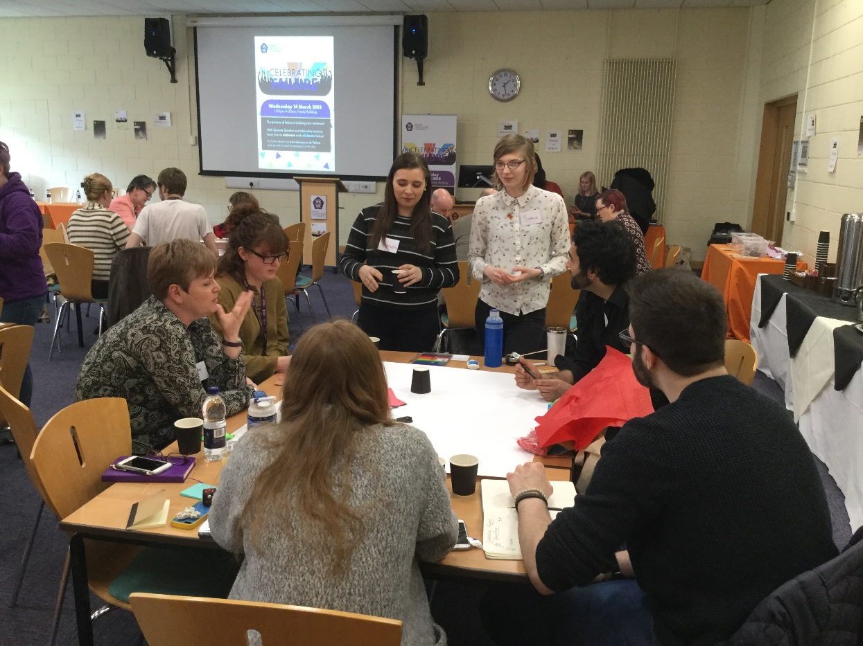
Students leading a poster workshop.
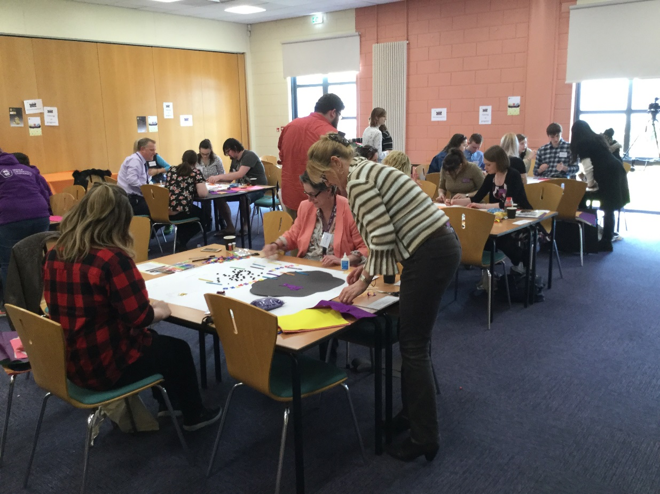
Students and staff working together.
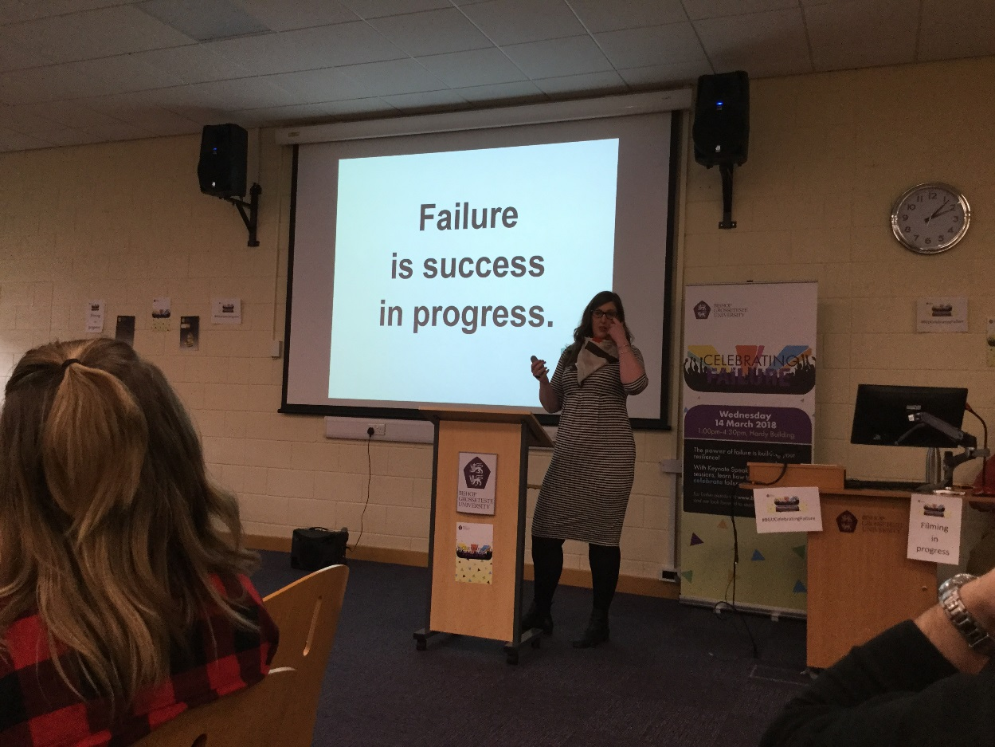
Keynote speech.
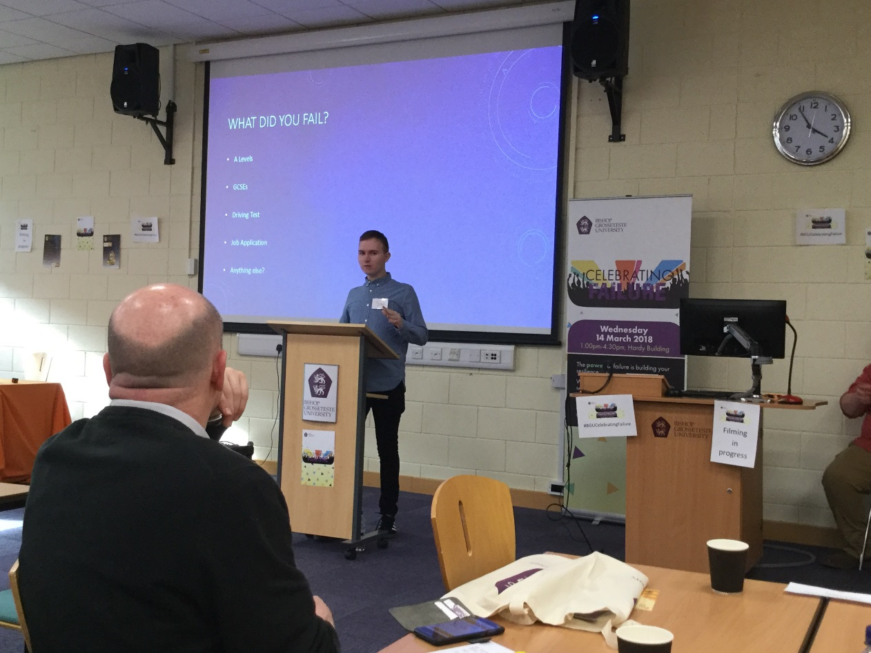
Student presentation on Minimum Viable Product.

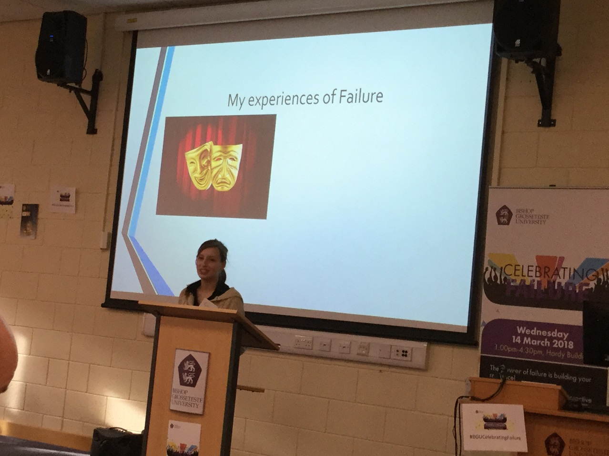
Student presentation on a personal experience of overcoming failure.

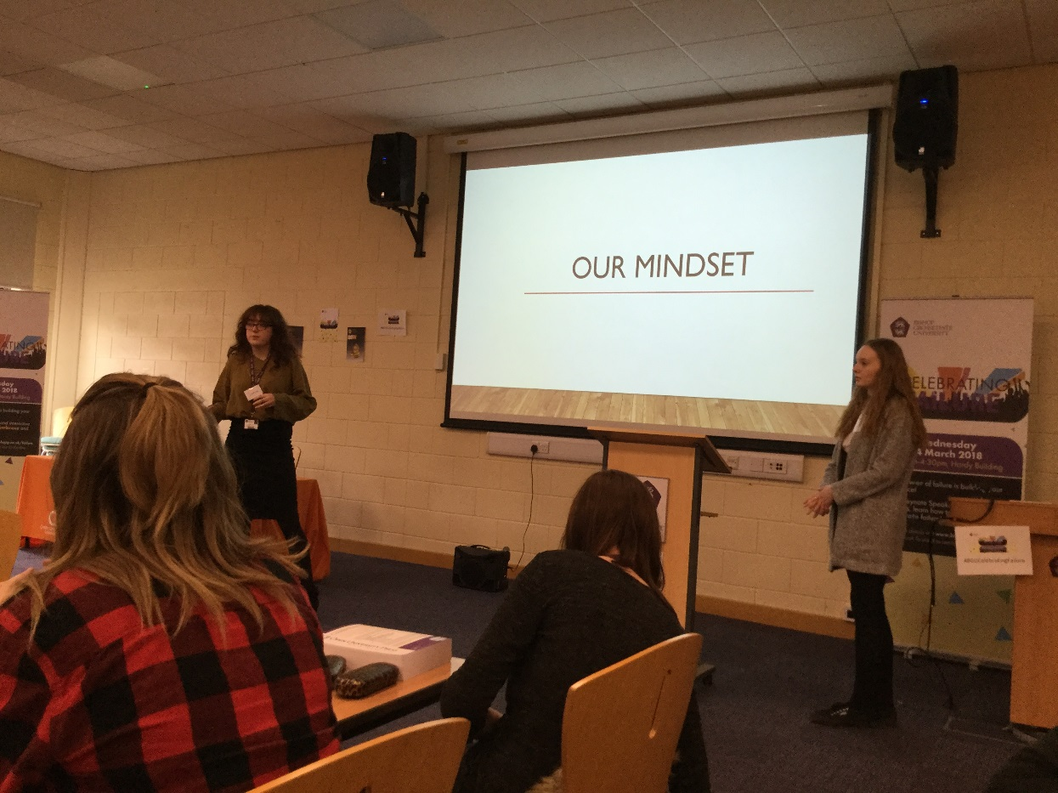
Student-led presentation on Mindset.
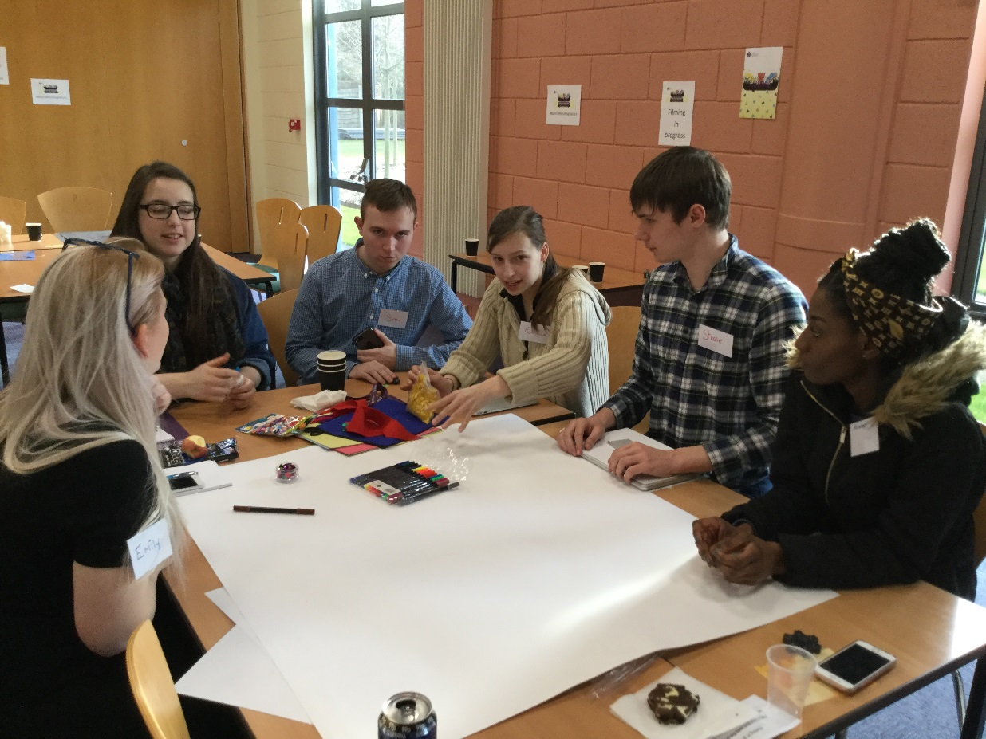
Students working on their "success" poster.

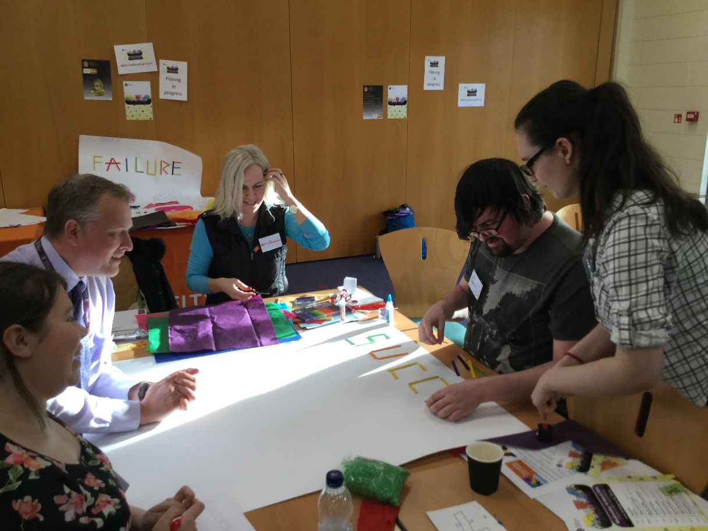
Student and staff working on their poster.

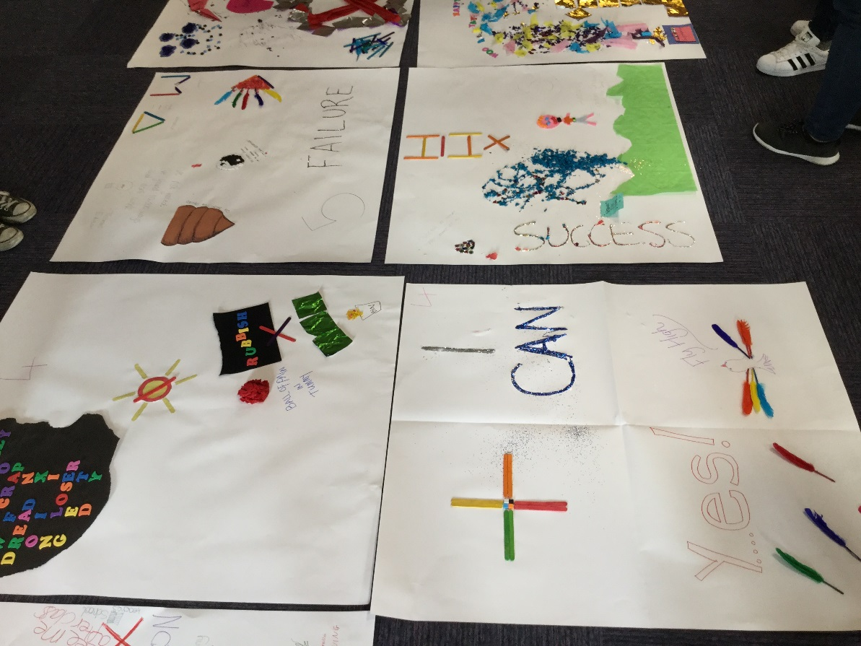
Posters created collaboratively during the workshops.

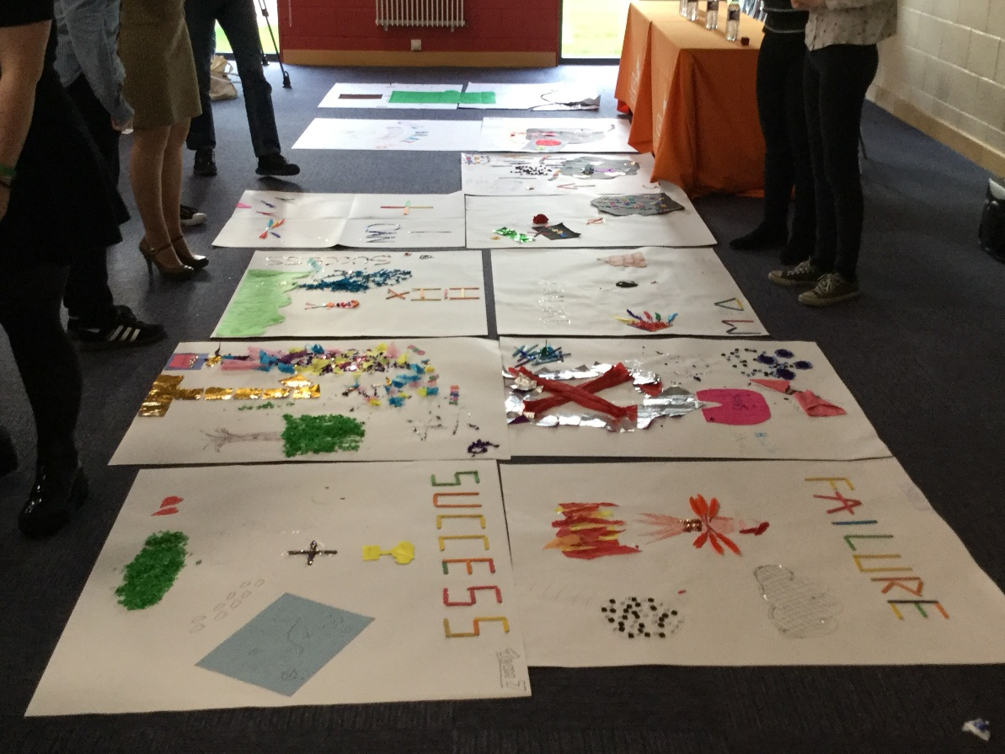
Posters created collaboratively during the workshops.

